Data Analytics Project:
Car Data Dataset Analysis

Dataset Used: cardata.csv

This document outlines a structured, end-to-end data analysis project based on the Car Data dataset. The project is divided into ten scenarios covering data cleaning, visualization, and advanced analysis.

Project Goal: To analyse car selling prices, fuel type distributions, and pricing patterns using the cardata.csv dataset.

The primary libraries/modules required for this project are:
- Pandas: For all data manipulation, filtering, aggregation, and feature engineering tasks.
- NumPy: Specifically for numerical calculations like price differences (np.diff).
- Visualization Library (e.g., Matplotlib): For generating all required plots (Line Graphs, Bar Charts, Pie Charts, Scatter Plots, Histograms).

Project Coverage:
Category | Skills Covered
Data Pre-processing | Data Loading, Missing Value Handling (Mean/Mode), Type Conversion
Pandas Operations | Grouping, Filtering, Aggregation, Feature Engineering (Car Age Category)
NumPy Calculations | Array conversion, Price difference calculation (np.diff)
Visualization | Line Chart, Bar Chart, Pie Chart, Scatter Plot, Histogram, Saving Plots

Scenario 1: Data Loading & Basic Cleaning
Description:
In this scenario we are loading the dataset to the pandas DataFrame and displaying the first 5 rows, last 5 rows, and column names. After that we are checking for any missing values in Selling_Price, Present_Price, Kms_Driven, and Fuel_Type columns. If found, we replace numeric columns with mean and Fuel_Type with mode. We also convert numeric columns to proper numeric type and use NumPy for basic statistical calculations.

Task | Description
1. | Load the dataset using Pandas.
2. | Display: First 5 rows, Last 5 rows, Column names, Shape of dataset.
3. | Check data types of all columns.
4. | Check for missing values in Selling_Price, Present_Price, Kms_Driven, Fuel_Type.
5. | Fill missing values: Selling_Price, Present_Price, Kms_Driven with mean; Fuel_Type with mode.
6. | Convert Selling_Price, Present_Price, Kms_Driven, Year to numeric type if required.
7. | Convert Selling_Price and Kms_Driven into NumPy arrays.
8. | Use NumPy to calculate minimum, maximum, and average selling price.

Conclusion:
In this scenario we loaded the CSV file to a pandas DataFrame and displayed the first and last 5 rows with column names and shape. We checked for missing values in key columns and handled them appropriately using mean/mode. The numeric columns were confirmed or converted to their proper types. Using NumPy arrays, we computed the minimum, maximum, and average selling prices for statistical insight.

Scenario 2: Selling Price Trend (Line Graph)
Description:
In this scenario, we work with car data to analyze selling price trends. First, we select only the required columns (Car_Name and Selling_Price) and limit the data to the first 10 records for simplicity. The Selling_Price values are then converted into a NumPy array to make them suitable for plotting. A line graph is created where the X-axis represents the index (0-9) and the Y-axis represents selling prices. Titles and labels are added along with markers to make the graph easy to understand. Finally, the graph is saved as an image file.

Task | Description
1. | Select Car_Name and Selling_Price columns.
2. | Take the first 10 rows only using Pandas.
3. | Convert Selling_Price into a NumPy array.
4. | Plot a line graph: X-axis → row index (0-9), Y-axis → Selling Price.
5. | Add title, x-axis label, y-axis label, and markers.
6. | Save the graph with a suitable filename.

Graph:
The graph is a line chart where the X-axis represents the index values (0-9) and the Y-axis represents the selling price of the cars. Each point on the graph shows the selling price of a car, and the points are connected by a line with markers. The graph helps in visualizing how the prices vary across the first 10 selected cars.

Conclusion:
This scenario shows how to visualize car selling price trends using a line graph. By selecting required data, limiting it to 10 records, and converting it into a NumPy array, we make the data ready for plotting. The line graph with markers helps to easily understand how prices change across entries, and adding labels improves clarity. Finally, saving the graph allows it to be used later for reports or analysis.

Scenario 3: Expensive Cars Analysis (Filtering + Bar Chart)
Description:
In this scenario, we analyze expensive cars by focusing on those with a selling price greater than 10. The filtered data is then grouped based on fuel type (such as Petrol or Diesel), and the number of cars in each category is counted. These results are converted into NumPy arrays to prepare them for visualization.A bar chart is created where the X-axis represents fuel types and the Y-axis represents the count of expensive cars. Titles and labels are added to improve clarity, and the graph is saved as an image file for future use.

Task | Description
1. | Filter cars where Selling_Price > 10.
2. | Group the filtered data by Fuel_Type.
3. | Count the number of cars in each fuel type.
4. | Convert fuel type labels and counts into NumPy arrays.
5. | Plot a bar chart: X-axis → Fuel Type, Y-axis → Count of expensive cars.
6. | Add title, x-label, and y-label.
7. | Save the graph.

Graph:
The graph is a bar chart where the X-axis represents the fuel type and the Y-axis represents the count of expensive cars (Selling_Price > 10). Each bar shows how many high-priced cars belong to a specific fuel type category. Taller bars indicate more expensive cars in that fuel type.

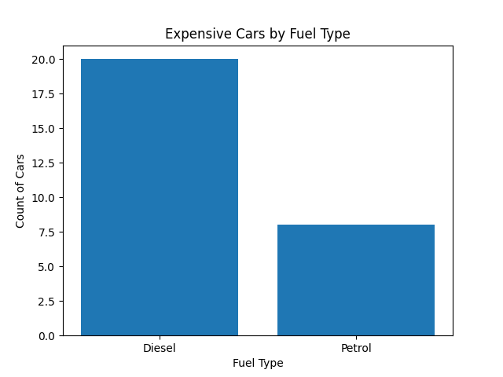

Conclusion:
This analysis identifies which fuel types are most common among expensive cars. By filtering cars with higher selling prices and counting them by fuel type, we can clearly see the dominant fuel category. The bar chart helps in easy comparison and visualization of distribution.

Scenario 4: Fuel Type Distribution (Pie Chart)
Description:
In this scenario we are analysing the overall distribution of cars by fuel type from the dataset. We count the number of cars in each Fuel_Type category, prepare labels and values, and represent the data graphically using a pie chart with percentage labels.

Task | Description
1. | Count the number of cars in each Fuel_Type.
2. | Select all categories or top categories if needed.
3. | Prepare labels and values.
4. | Convert values into a NumPy array.
5. | Plot a pie chart using Matplotlib.
6. | Add percentage labels (autopct) and title.
7. | Save the graph.

Graph:
The pie chart visually represents the proportion of cars in each fuel type category. Each slice shows the percentage of cars belonging to that fuel type. The chart makes it easy to compare the relative sizes of each fuel type group in the dataset.

Conclusion:
In this scenario we sorted the dataset to get cars categorised depending on fuel type. From the output and the pie chart, we can determine which fuel type dominates the dataset. This helps understand the overall composition of car types in the market represented by the data.

Scenario 5: Present Price vs Selling Price (Scatter Plot)
Description:
This scenario checks whether cars with higher present price also have higher selling price. We select Present_Price and Selling_Price columns, remove any missing values, and take a smaller sample (first 50 or 100 rows) for clarity. Both columns are converted to NumPy arrays and plotted on a scatter plot to observe any positive relationship between the two variables.

Task | Description
1. | Select Present_Price and Selling_Price columns.
2. | Remove missing values if any.
3. | Take a smaller sample (first 50 or 100 rows) using Pandas.
4. | Convert both columns into NumPy arrays.
5. | Plot a scatter plot: X-axis → Present_Price, Y-axis → Selling_Price.
6. | Add title, x-label, and y-label.
7. | Observe whether there is a positive relationship.
8. | Save the graph.

Graph:
The scatter plot shows the relationship between Present_Price on the X-axis and Selling_Price on the Y-axis. Each dot represents a car. A positive trend (dots moving upward from left to right) indicates that cars with higher present prices tend to have higher selling prices as well.

Conclusion:
The scatter plot confirms that there is generally a positive relationship between present price and selling price. Cars with a higher market price (present price) tend to be sold at a higher price as well. However, there is some variation due to factors like car age, mileage, and condition that affect depreciation differently.

Scenario 6: Car Age Category Analysis + Bar Chart
Description:
In this scenario, we create a new feature 'Car Age Category' based on the Year column to classify cars into New, Medium, and Old categories. We then count the number of cars in each category, convert the results into NumPy arrays, and plot a bar chart to compare the distribution of cars across age groups.

Task | Description
1. | Create a new column 'Car Age Category' using Pandas.
2. | Year >= 2015 → 'New', 2010 to 2014 → 'Medium', < 2010 → 'Old'.
3. | Count the number of cars in each Car Age Category.
4. | Convert category names and counts into NumPy arrays.
5. | Plot a bar chart: X-axis → Car Age Category, Y-axis → Count.
6. | Add title and labels.
7. | Save the graph.

Graph:
The bar chart displays the number of cars in each age category (New, Medium, Old) on the X-axis, with the count on the Y-axis. Each bar's height represents how many cars fall into that age bracket, giving a clear visual comparison of car age distribution in the dataset.

Conclusion:
The car age category analysis helps understand the age composition of cars in the dataset. The bar chart clearly shows which age group dominates the market. This feature engineering step demonstrates how raw year data can be transformed into meaningful categorical labels for better business insight.

Scenario 7: Kms Driven Distribution (Histogram)
Description:
This scenario focuses on understanding how cars are distributed based on kilometers driven. We select the Kms_Driven column, convert it into a NumPy array, and plot a histogram with suitable bins to observe whether most cars have lower or higher mileage.

Task | Description
1. | Select the Kms_Driven column.
2. | Convert it into a NumPy array.
3. | Plot a histogram: X-axis → Kms Driven, Y-axis → Frequency.
4. | Choose a suitable number of bins.
5. | Add title, x-label, and y-label.
6. | Save the graph.
7. | Observe whether most cars have lower or higher mileage.

Graph:
The histogram displays the frequency distribution of Kms_Driven values in different ranges. It shows how many cars fall within each mileage interval. The shape of the distribution helps identify whether the dataset is dominated by low-mileage or high-mileage cars.

Conclusion:
The histogram reveals the mileage distribution of cars in the dataset. Most cars tend to be concentrated in the lower mileage ranges, indicating that the dataset contains a majority of relatively less-used cars. There are a few outliers with very high mileage. This insight is useful for understanding the overall usage patterns of vehicles in the dataset.

Scenario 8: Transmission-wise Selling Price Comparison
Description:
In this scenario, we analyze car data to compare the average selling prices of manual and automatic cars. The dataset is grouped based on the Transmission type, and the mean of Selling_Price is calculated for each group. This helps in understanding how pricing differs between transmission types.The transmission categories and their corresponding average prices are then converted into NumPy arrays for visualization. A bar chart is plotted where the X-axis represents transmission types (Manual, Automatic) and the Y-axis represents their average selling prices. Titles and labels are added for clarity, and the graph is saved as an image file.

Task | Description
1. | Group data by Transmission.
2. | Calculate average Selling_Price for each transmission type.
3. | Convert transmission labels and average prices into NumPy arrays.
4. | Plot a bar chart: X-axis → Transmission, Y-axis → Average Selling Price.
5. | Add title and labels.
6. | Save the graph.

Graph:
The bar chart displays two bars representing Manual and Automatic transmission types on the X-axis, with the average selling price on the Y-axis. The height of each bar directly reflects the average price for that transmission type, making it easy to compare the two groups.

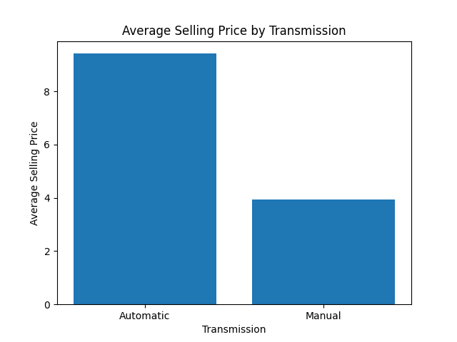

Conclusion:
This analysis compares the average selling price of manual and automatic cars. By grouping the data based on transmission and calculating the mean price, we can clearly see which type tends to be more expensive. The bar chart makes this comparison easy to understand visually.

Scenario 9: Seller Type Analysis
Description:
This scenario compares how many cars are sold by dealers versus individual sellers. We count the number of cars by Seller_Type, convert the results into NumPy arrays, and plot a bar chart or pie chart to identify which seller type is more common in the dataset.

Task | Description
1. | Count the number of cars by Seller_Type.
2. | Convert results into NumPy arrays.
3. | Plot a bar chart or pie chart using Matplotlib.
4. | Add labels and title.
5. | Save the graph.
6. | Identify which seller type is more common.

Graph:
The chart visualizes the number of cars listed by each seller type (Dealer vs Individual). Whether presented as a bar chart or pie chart, it clearly shows the proportion of cars coming from each seller type and helps identify the dominant source in the dataset.

Conclusion:
The seller type analysis shows that dealers tend to list more cars than individual sellers in the dataset. This indicates that the used car market represented in this data is largely driven by dealer sales. Understanding seller type distribution is useful for pricing strategies and market positioning.

Scenario 10: Advanced Analysis + Multiple Graphs
Description:
This scenario focuses on advanced data analysis of the car dataset using feature engineering, NumPy operations, and visualizations. A new feature 'Price Difference' is created to measure depreciation. NumPy is used to analyse price differences for numerical insights. Multiple graphs are generated to understand trends, distributions, and relationships in the data. Finally, statistical analysis is used to derive meaningful business insights.

Part 1: Feature Creation
Create a new column: Price Difference = Present_Price - Selling_Price. This shows how much value the car has depreciated.

Part 2: NumPy Usage
Task | Description
1. | Convert Selling_Price into a NumPy array.
2. | Use np.diff() to calculate price changes between consecutive rows.
3. | Convert Price Difference column into a NumPy array.
4. | Find average depreciation, maximum depreciation, and minimum depreciation.

Part 3: Visualizations
Task | Description
Line Graph | Plot Selling_Price trend for all cars.
Bar Chart | Show average Selling_Price by Fuel_Type.
Histogram | Plot distribution of Selling_Price.

Part 4: Insights
- Which fuel type has the highest average selling price?
- Which transmission type has higher average selling price?
- Are most cars concentrated in lower selling prices or higher selling prices?
- Do older cars tend to have lower selling prices?

Graphs:
Three graphs have been plotted — a Line graph, Bar Chart, and Histogram — for better visualization.

Line Graph
This line graph shows the variation of car selling prices across all records in the dataset. Each point represents a selling price plotted in sequence. It helps visualize how prices fluctuate throughout the dataset and highlights outliers in pricing.

Bar Chart
This bar chart shows the average selling price for each fuel type. Each bar represents a fuel type and its height shows the average selling price in that category. It helps compare how fuel type influences pricing.

Histogram
This histogram displays the frequency distribution of car selling prices in different ranges. It shows how many cars fall within each price interval and helps identify the overall shape of the price distribution.

Conclusion:
This scenario provided a complete analysis of the car dataset using feature engineering, NumPy operations, and visualizations. A new 'Price Difference' feature helped measure depreciation clearly. Graphical analysis showed how prices vary across cars and revealed important patterns in the data. Most cars fall under the lower selling price range, while a few high-value cars skew the distribution. Overall, the dataset shows a right-skewed price distribution with diesel cars commanding higher prices on average.

Final Conclusion
This project analysed the Car Data dataset using Pandas, NumPy, and Matplotlib. It showed that petrol cars dominate the dataset, while diesel cars tend to command higher selling prices. Most cars fall in the lower selling price range, indicating a right-skewed price distribution. Automatic transmission cars have a higher average selling price than manual ones. The data visualizations helped clearly understand patterns in car pricing, fuel type distribution, and mileage. Overall, the analysis gave useful insights into the used car market represented in the dataset.

What We Have Learned
In this project, we have learnt how to clean and process real-world car sales data using Pandas and perform numerical calculations using NumPy. We have also learnt how to create different visualizations like line graphs, bar charts, pie charts, scatter plots, and histograms using Matplotlib. Additionally, we learnt feature engineering techniques such as creating 'Car Age Category' and 'Price Difference' columns. Most importantly, we understood how to turn raw car sales data into meaningful insights using an end-to-end data analysis process.

Best Columns to Use in This Dataset
Numeric Columns | Categorical Columns
Selling_Price | Fuel_Type
Present_Price | Seller_Type
Kms_Driven | Transmission
Year
Owner

